Welcome to our Zoom pack!



Everything you need to complete your badge and participate in the zoom meeting is contained in this booklet.

The booklet is available:-
- on our website www.2ndrenfrewtrinityscoutgroup.org.uk
- via link on our Group Facebook page
- or a hardcopy can be collected from hall

Friday Cubs Zoom meeting will take place on Friday 15th January at 7.30pm

Please use the link and password provided on Group Facebook page.

Monday Cubs Zoom meeting will take place on Monday 18th January at 7.30pm. Please use the link and password provided on Group Facebook page.

Please read through the booklet in advance of our meeting. It will tell you what you should have completed in advance and what we will do together at our meeting. Remember Cubs is supposed to be fun so don’t worry if you can’t do it all!

The Scout website give the criteria as follows but we will have to get a bit creative and adapt for our current situation!

Our Skills Challenge Award


How to earn your award
- Try two new sports or physical activities at least once. You could try:
  - tennis
  - dance
  - basketball
  - tai chi.

- Take part in three activities to help you be healthy, like:
  - healthy eating
  - exercise
  - learning how the human body works
  - another activity agreed with your leader.

- Pick two creative things to try and show your leader what you’ve done. You could:
  - write a short story
  - make a model
  - take some photos and use them to tell a story
  - be part of a play or sketch.

- Learn and use at least four of these skills:
  - sew on a button or badge
  - make cakes, bread, biscuits or something similar
  - oil a bicycle chain, change a wheel or fit lights
  - make a cup of tea or coffee, then wash up afterwards
  - lay a table for a meal
  - peel potatoes or other vegetables
  - iron your scarf
  - change a lightbulb, in a table or standard lamp
  - clean a window
  - tidy and clean your bedroom
  - another similar home skill agreed with your leader.

- Take part in at least two problem solving activities that you haven’t done before. It should be something that you need to think creatively for. As part of the activity you need to say what you found difficult, what you did to solve the problem, and why.

Part.1 Try a new sport or physical activity at least once.

So we may not be able to get in the pool or on a tennis court just now but there are plenty of other things we can be doing.

GET OUTDOORS
Perhaps some of you have been making the most of recent snowfall and tried sledging in the park or up the Braes.
Go to the park!
- Why not challenge yourself and try to run a kilometre or even more!
- Perhaps you have a new scooter or skateboard. Get working on those skills!

INDOOR FUN
There are plenty of online fitness videos that might inspire you.
- Why not workout with Joe Wicks
- Work on your flexibility

Let us know at our zoom chat what you have been up to. Did you try something new that you love and will keep doing it. Or maybe you tried something you didn’t like.
It is all good …..

All these forms of exercise keep us healthy and that’s what we will look at next in Part 2.

Part.2 Take part in three activities to help you be healthy.

When you were trying out your new sport or activity did you notice what happened to your body? Did you get warmer, did you breathe quicker, did you feel your heart beating faster?

Find out what happens to your heart rate when you do physical activities.
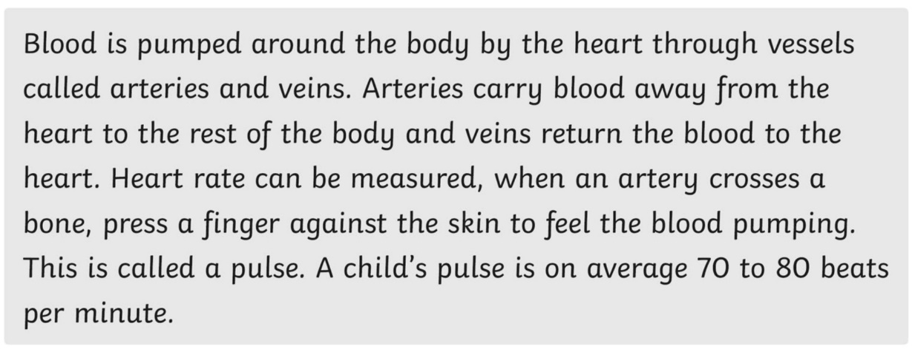

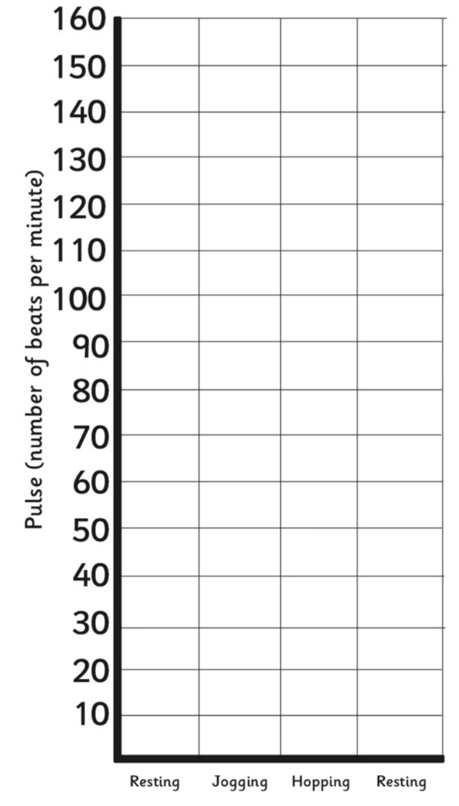
Before you begin, take your ‘resting’ pulse and record it on the chart.
Now jog around your garden or just on the spot for one minute and take your pulse again. Record it on the chart.
Next try hopping for a minute. Take your pulse again and record it on te chart.
Finally a two minute rest! Then take and record your pulse.
Hint – Count your pulse for 10 seconds and then times by 6

This booklet also contains three healthy eating activities for you to try. Do one or all of them it’s up to you.
- Food diary
- Wordsearch
- Food-doku

These are based on the Eatwell Guide. Remember the main food groups on the Eatwell Guide: fruit and vegetables, carbohydrates, proteins, fats/oils and dairy. Everyone should be aware of the amounts of these foods that are needed for a healthy lifestyle.
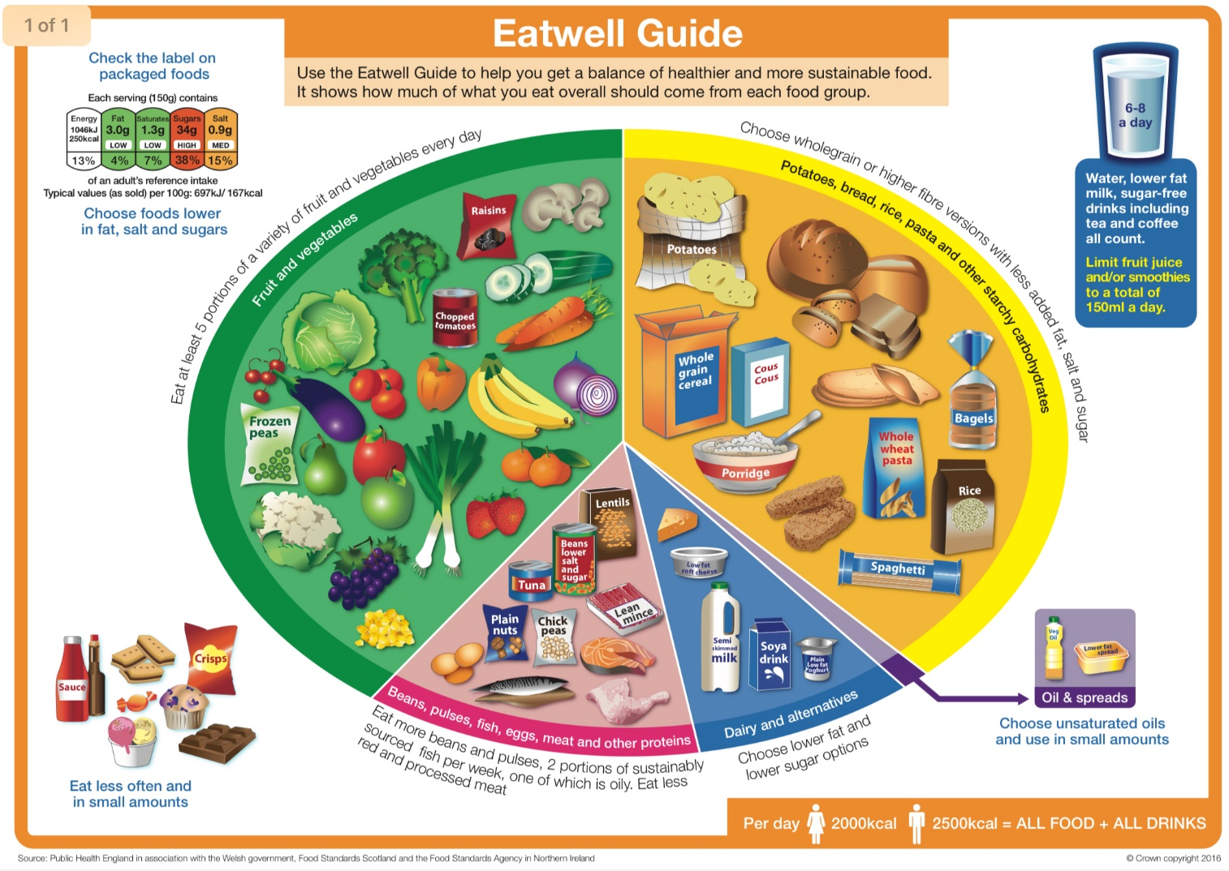
The Eatwell Guide shows how much of what we eat overall should come from each food group to achieve a healthy, balanced diet. You do not need to achieve this balance with every meal, but try to get the balance right over a day or even a week.
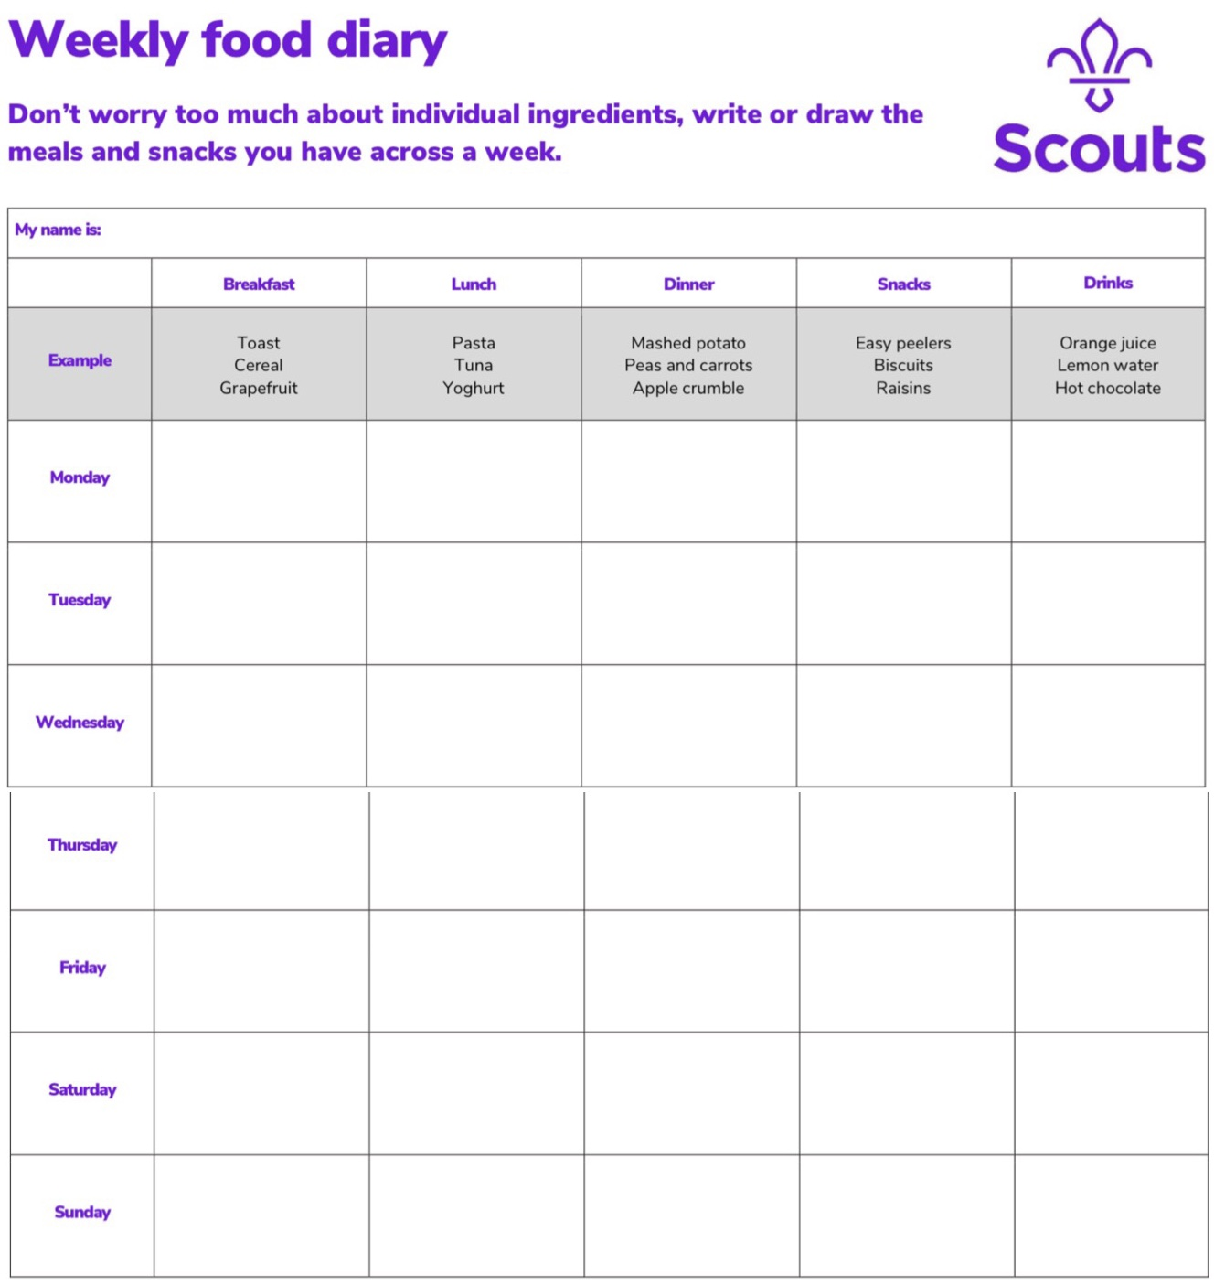
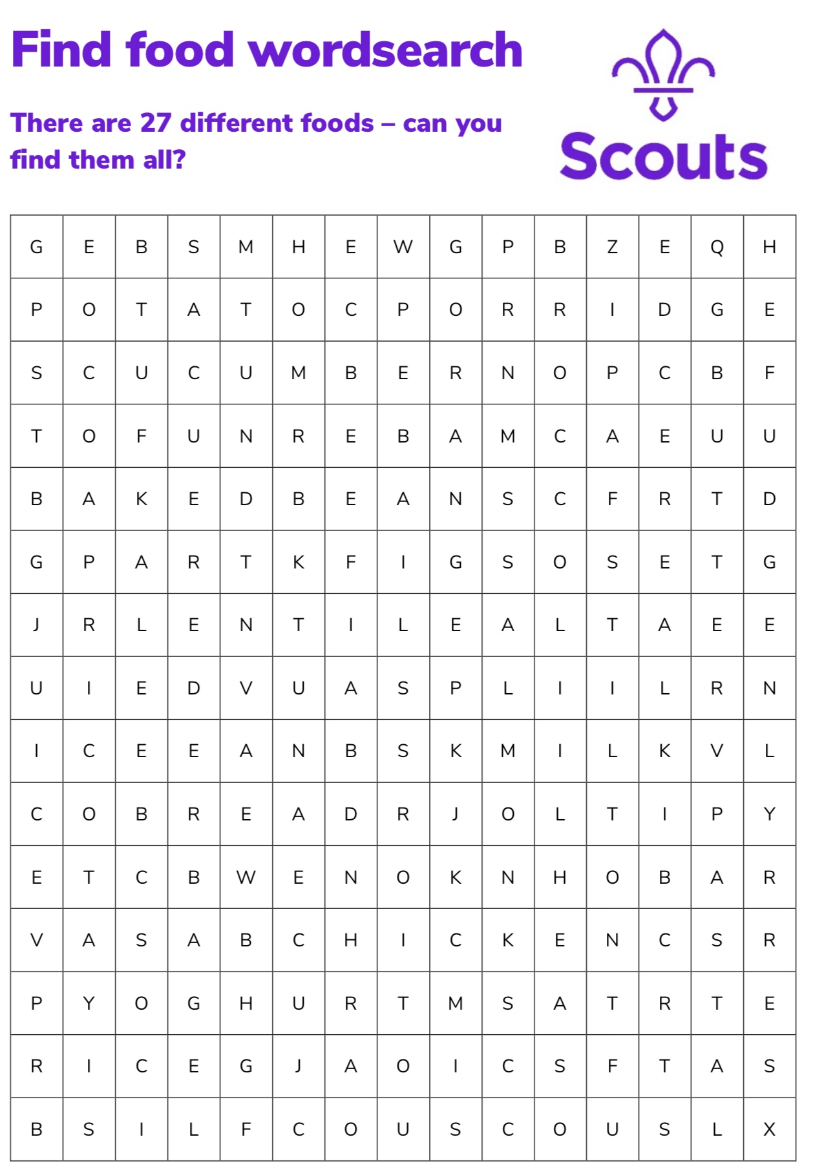
Fruit & veg – cucumber, broccoli, orange, kale, apricot, juice, figs
Proteins – tofu, baked beans, lentils, tuna, chicken, salmon, beef
Carbohydrates – potato, porridge, cereal, pasta, rice, couscous, bread, bagel
Dairy – butter, milk, stilton, yoghurt
Treats - fudge


You will need
- Scissors
- Glue sticks
- Coloured pens or pencils

Before you begin
- Print the ‘Food-doku puzzles, templates and pictures’ sheet. Cut out the food images on page 9 with scissors.
What to do
- To complete a smaller grid, place the food symbol cut-outs into the empty squares in a way that makes every row and column (up-and-down or side-to-side) of foods make up a balanced diet. Each row or column should contain at least one fruit, vegetable and carbohydrate, and a protein, piece of dairy or glass of water. In larger grids, each row or column should contain each food symbol only once.
Start with the ‘beginner’ puzzle, move onto the ‘intermediate’ puzzle and try the ‘advanced’ puzzle if you have time.

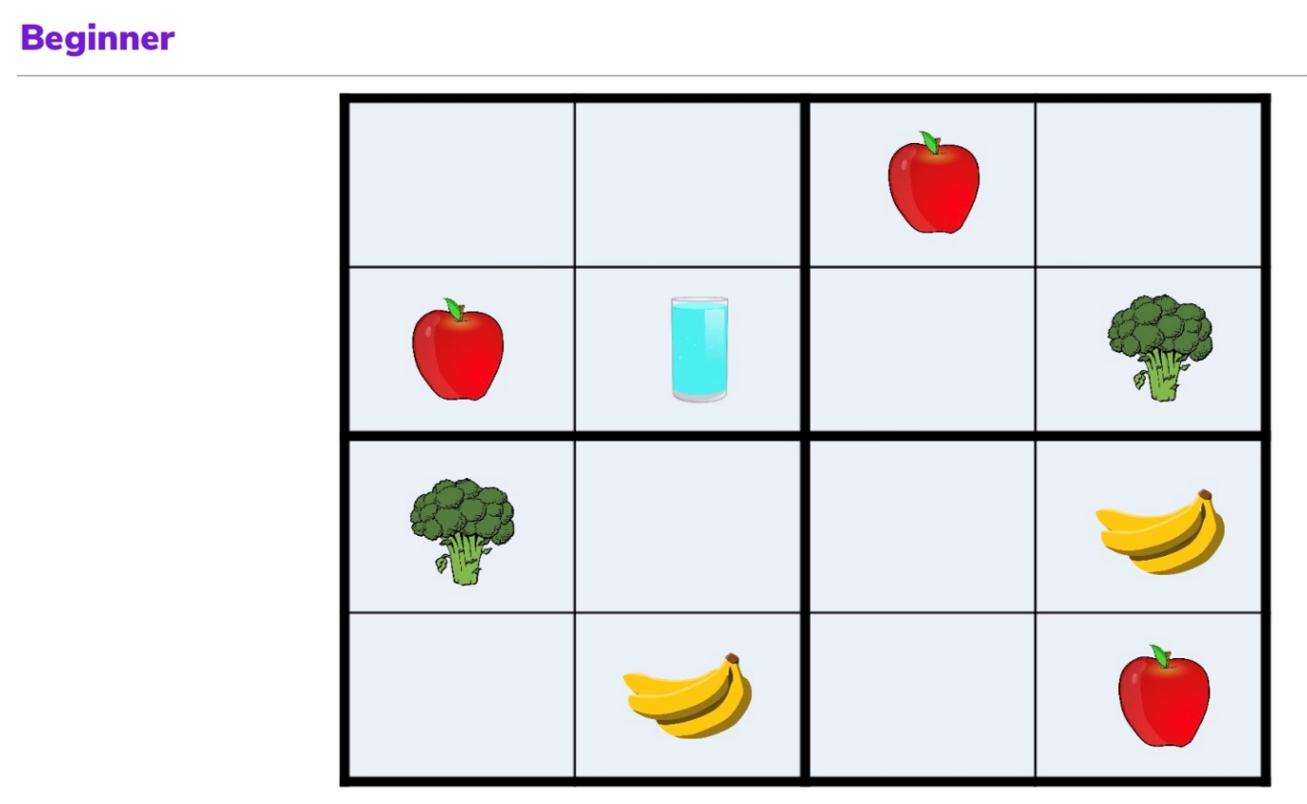
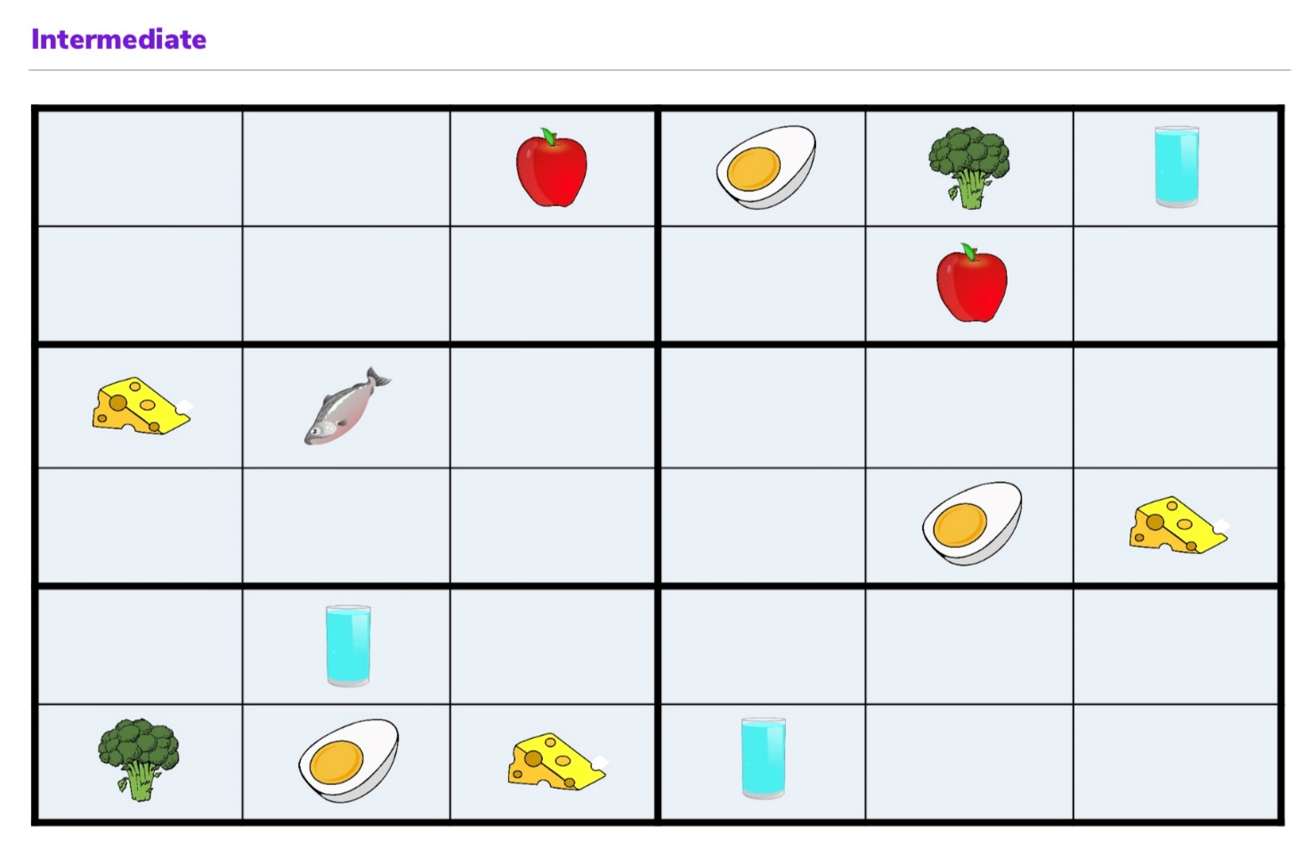
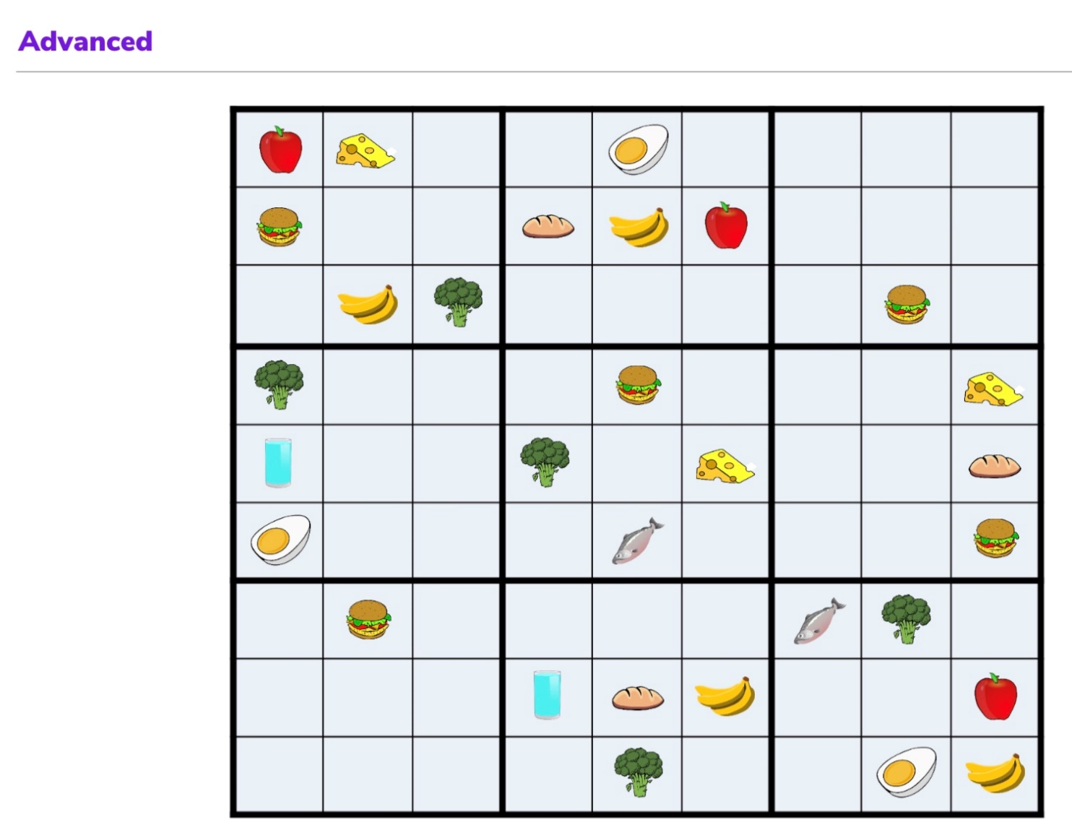
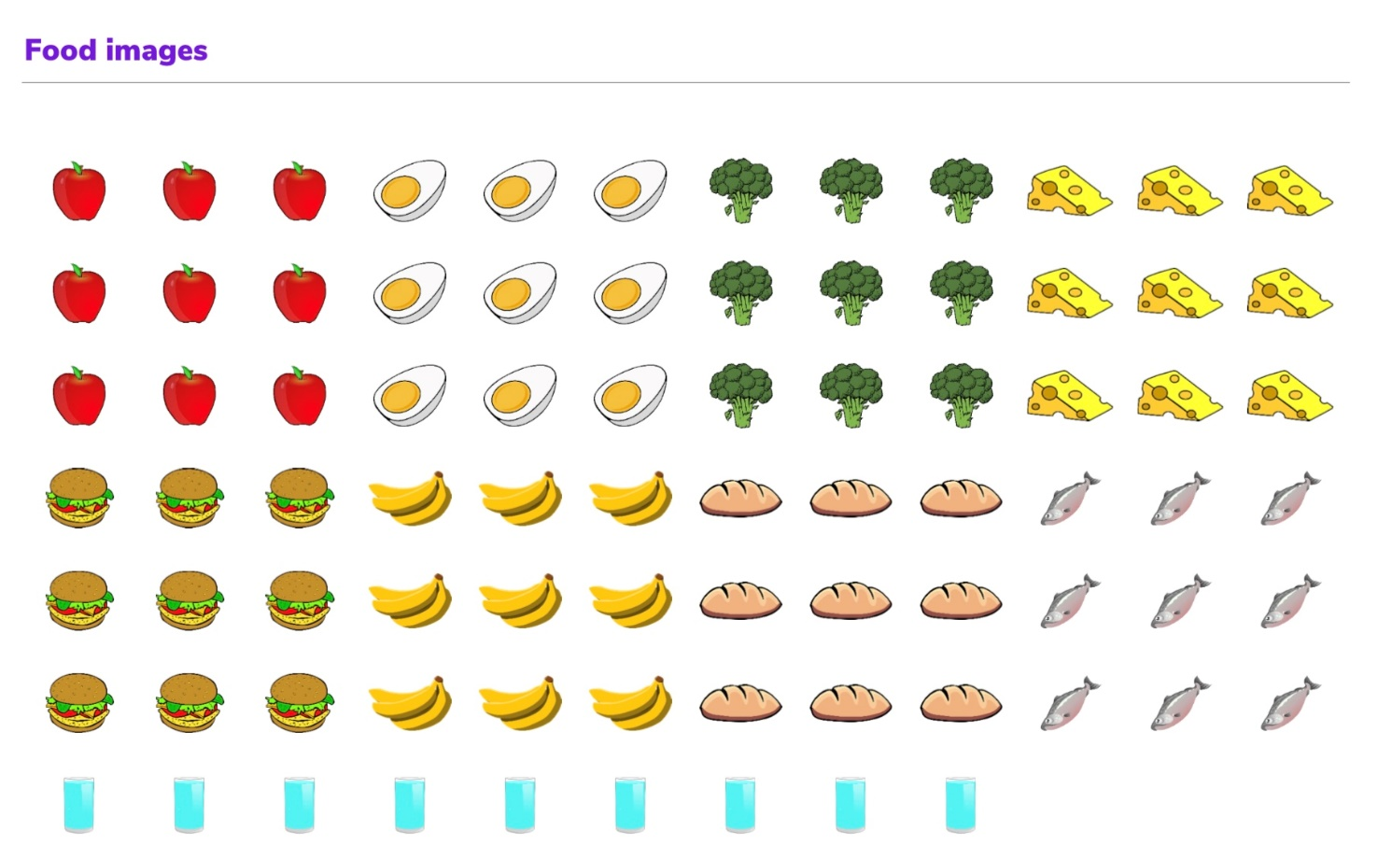

Part 3 Do two creative things

I know that you all made some really great crafts for Christmas and how creative you can be! Perhaps you even made your own gifts for family and friends that were really appreciated.
Maybe you created the most amazing snowman!
Tell us, or even show us, at our zoom chat what you made.

As it is New Year why not try creating your own mnemonic of what you hope for in 2021.
N
E
W
Y
E
A
R

Our next Zooom Pack is based on International Activity Badge and it will contain details of how to make Chinese window flowers and lanterns. So don’ worry if you don’t get time to get creative this week we’ve got you covered next time!

Part 4 Learn and use four skills

Here is a reminder of some of the skills for you to try. Tick off the ones you have mastered and feel free to add your own.
 | sew on a button or badge |  | make cakes, bread, biscuits or something similar
 | iron your neckie |  | make a cup of tea or coffee, then wash up afterwards
 | clean a window |  | lay a table for a meal
 | change a lightbulb, in a table or standard lamp |  | peel potatoes or other vegetables
 | tidy and clean your bedroom |  | Look after your pet
 | help with the laundry |  | Your choice! Tell us …..
 | oil a bicycle chain, change a wheel or fit lights |  | Your choice! Tell us …..

Part 5 Take part in two problem solving activities

If you completed the wordsearch and sudoku earlier in the booklet then you are already on your way to completing Part 5!

We will do the activity below on our Zoom chat so be prepared with your letter tower!
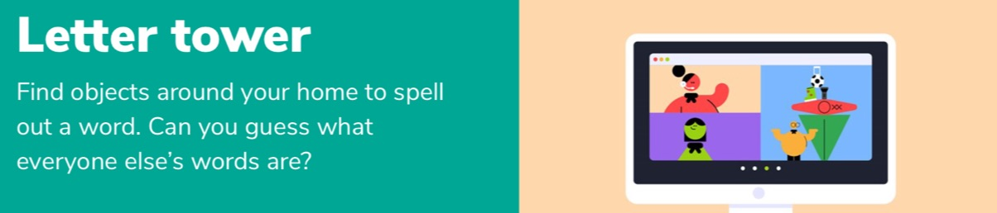
- Choose a six letter word and find an object that begins with each letter of the word you chose. For example, if you choose the word circus, you could find a chair, icecube tray, ruler, cookbook, umbrella and a spoon.
- Build a tower from these objects.

Need a bigger challenge! How big a word can you spell in your tower before it topples!!

